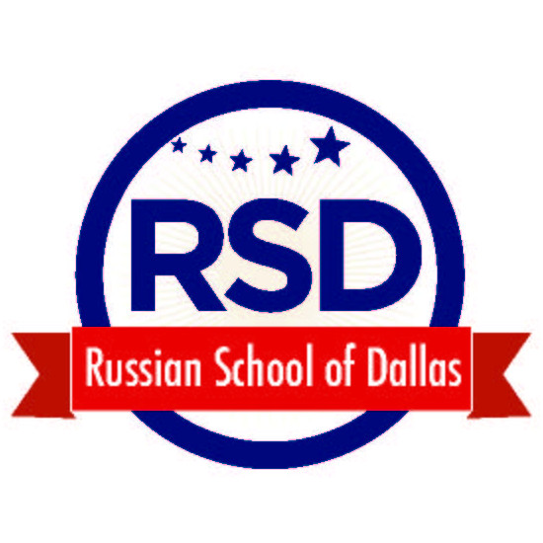
6039 Churchill Way
Dallas, Texas 75230
www.russianschoolofdallas.com
Tel: (214) 364-7674

APPLICATION FOR ADMISSION*

_____________________________________________________________
STUDENT’S NAME (First, Middle, Last)
_____________________________________________________________
Address (Street, City, State, Zip Code)

Russian speaker □
English speaker □ DATE OF BIRTH _______________

Please, check both if bi-lingual (Month/Day/Year)

□ Female
□ Male

*An application is considered to be complete when the school
has received the following:

• A completed application form with a Signature of parent or guardian
• A non-refundable $50 application fee (for new students) and tuition fee.
Checks or cash only.
THERE IS NO ENROLLMENT ON LINE.
Please send your payments and application forms to:
Russian School of Dallas
6039 Churchill Way
Dallas TX 75230

CANCELLATION

The Russian School of Dallas reserves the right to cancel any course that is undersubscribed. In that event, paid tuition will be refunded in full.

Payment can be prorated.
Siblings have 10% discount.

PARENT STATEMENT

MOTHER’S INFORMATION

______________________________________________________________________________________
􀀀 Ms. 􀀀 Mrs. 􀀀 Dr. (First, Middle, Last)

________________________________________ ___________________________________________
Home Number Mobile Phone

________________________________________ ___________________________________________
Native Language Employer, Type of Business, Position

________________________________________
E-Mail

FATHER’S INFORMATION

______________________________________________________________________________________
􀀀 Mr. 􀀀 Dr. (First, Middle, Last)

______________________________________________________________________________________Address (Street, City, State, Zip Code)

________________________________________ ___________________________________________
Home Number Mobile Phone/Pager

________________________________________ ___________________________________________
Native Language Employer, Type of Business, Position

______________________________________________________________________________________
E-Mail

SIBLINGS (Names, Ages)

_________________________________________ __________

_________________________________________ __________

_________________________________________ __________

IN CASE OF EMERGENCY CONTACT (Other than a parent)

________________________________________________________________________ 􀀀 Ms. 􀀀 Mrs. 􀀀 Dr (First, Middle, Last )

______________________________________________________________________________________
Address (Street, City, State, Zip Code)

_________________________________________ ___________________________________________
Home Number Mobile Number

______________________________________________________________________________________
Relationship to Child

MEDICAL HISTORY

Is the student currently taking any medication ? 􀀀Yes 􀀀 No

If yes, please specify _____________________________________________________________________

Does the applicant have a physical handicap, chronic illness or allergy? 􀀀 Yes 􀀀 No

If yes, please explain. Include information regarding any special arrangements that you may need:

______________________________________________________________________________________

- I agree to the videoing and/or photographing of my child during RSD activities for use by RSD in educating children and promoting RSD and public education. I also agree to the publication of images of my child(ren) in Internet websites, RSD newsletters in print, RSD newsletters online, Magazines, Local newspaper7

________________________________________ ______________
Mother’s, Father’s, or Legal Guardian’s Signature Date

The Russian School of Dallas does not discriminate on the basis of race, gender, color, religion, national or ethnic origin, or handicap in administration of its educational policies, admissions policies, or in its employment practices.

